Ministry of Education and Science of Republic of Kazakhstan

Department of Cybersecurity

Sentiment Analysis on Twitter

Completed:
Akbergen Kaisar(34731)
Yesmaganbet Shyngys(34877)
Buralkhy Abay(34832)
Group: SIS-2201

Almaty 2025

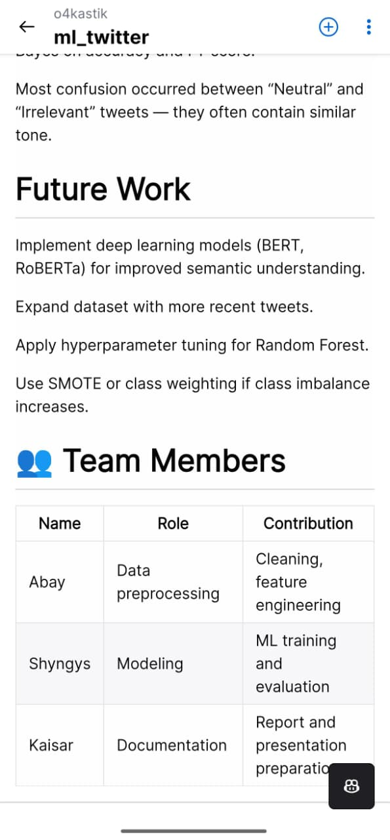

1. Problem Understanding
Project Objective:
The goal of this project is to classify tweets into three sentiment categories: positive, negative, or neutral using Natural Language Processing (NLP) and machine learning techniques. By building an automated system, we aim to extract meaningful insights from large volumes of Twitter data, which would be impossible to analyze manually.
Problem Importance:
Analyzing public sentiment on social media is crucial for businesses, researchers, and policymakers. It helps to:
- Monitor brand reputation
- Understand public reactions to events or products
- Identify trends and potential crises
Role of Machine Learning:
Machine learning allows the automatic classification of textual data. Traditional rule-based methods are insufficient for large-scale Twitter data due to noisy text, abbreviations, slang, and emojis. ML models such as Naive Bayes or Logistic Regression can learn patterns from the data and generalize to new, unseen tweets.
Input, Output, and Constraints:
- Input: Raw text of tweets (text)
- Output: Sentiment label (positive, negative, neutral)
- Constraints:
  - Tweets are short and may contain slang, emojis, or special characters
  - Data may be imbalanced across classes
  - Efficient processing is required for large datasets

2. Dataset Handling + Preprocessing
Dataset Description:
For this project, we used two datasets: twitter_training.csv and twitter_validation.csv. Each dataset contains four columns: id, entity, sentiment, and text. The training dataset contains N samples, while the validation dataset contains M samples. The target variable is sentiment, which has three classes: positive, negative, and neutral.
Data Preprocessing Steps:
- Checking for missing values and duplicates:
We verified that there were no missing values and removed duplicate rows to ensure data quality.
- Text Cleaning:
The following steps were applied to clean the tweets:
  - Convert all text to lowercase
  - Remove URLs, mentions (@username), and hashtags (#hashtag)
  - Remove numbers and punctuation
  - Strip leading and trailing spaces
- Feature Engineering:
A new feature text_length was created to represent the number of characters in each tweet.
- Text Vectorization:
The cleaned text was transformed into numerical features using TF-IDF vectorization. We set a maximum of 5000 features and removed English stop words.
Data Visualizations:
- Sentiment distribution in the training dataset (bar chart)
- Tweet length distribution (histogram)

3. Exploratory Data Analysis
Purpose of EDA:
Exploratory Data Analysis (EDA) helps us understand the structure, patterns, and relationships in the dataset before training machine learning models. It allows us to identify class imbalances, unusual distributions, and potential preprocessing improvements.
EDA Steps and Findings:
- Sentiment Distribution:
We analyzed the distribution of sentiment classes in the training dataset. The majority of tweets were neutral, followed by positive and negative classes.
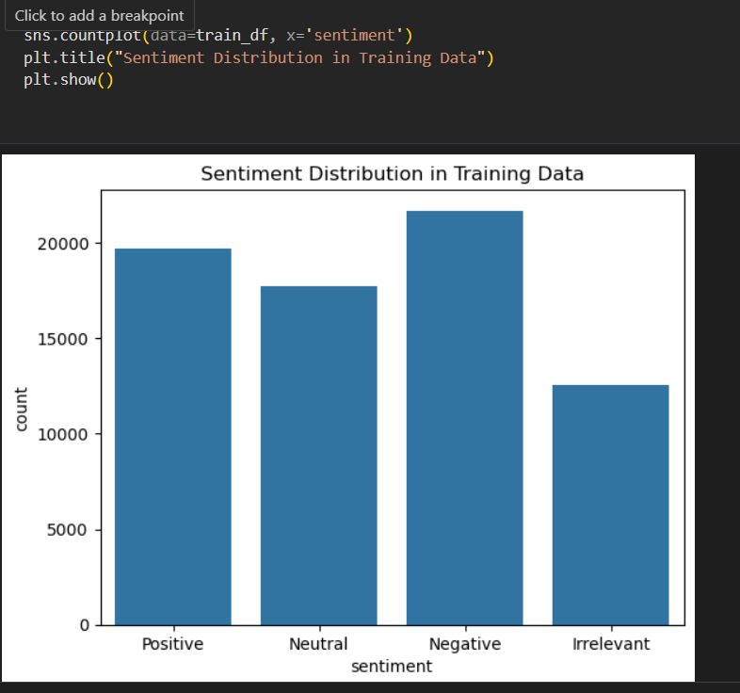

Insight: The dataset is slightly imbalanced, which may affect model performance.

Tweet Length Analysis:
We examined the length of tweets to understand text characteristics. Most tweets have fewer than 100 characters, with a small number of longer tweets.
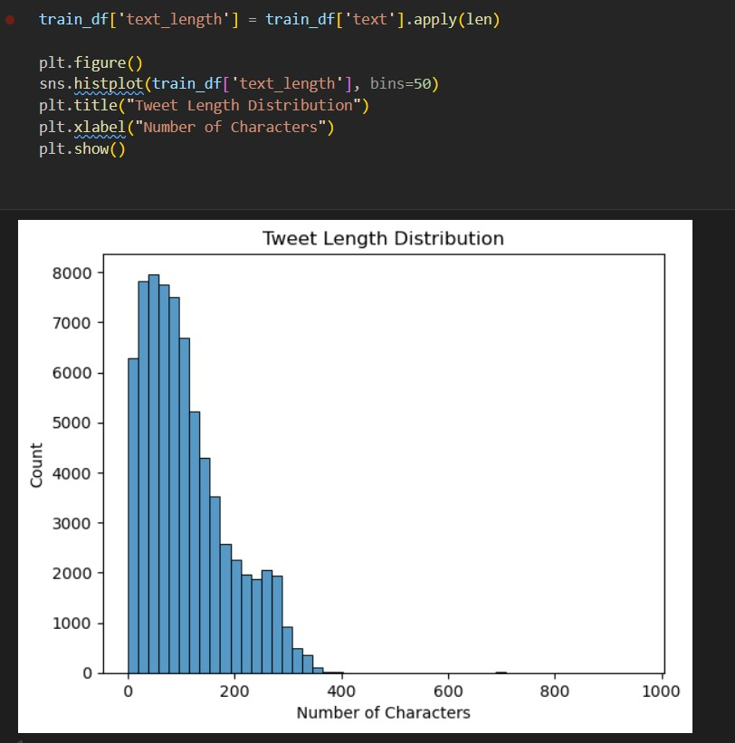
Insight: Short text length may limit context, which is important for NLP models.

4. Model Development & Tuning
Objective:
In this stage, we develop machine learning models to classify tweets by sentiment. We use two models: Naive Bayes as a baseline and Logistic Regression as an improved model with hyperparameter tuning.
Model Selection:

- Naive Bayes (MultinomialNB):
  - Simple and fast, suitable for text classification.
  - Often used as a baseline to evaluate minimum performance.

- Logistic Regression:
  - Powerful classification model with tunable hyperparameters (C, solver, max_iter).
  - Usually performs better on text data with TF-IDF features.

Model Training:
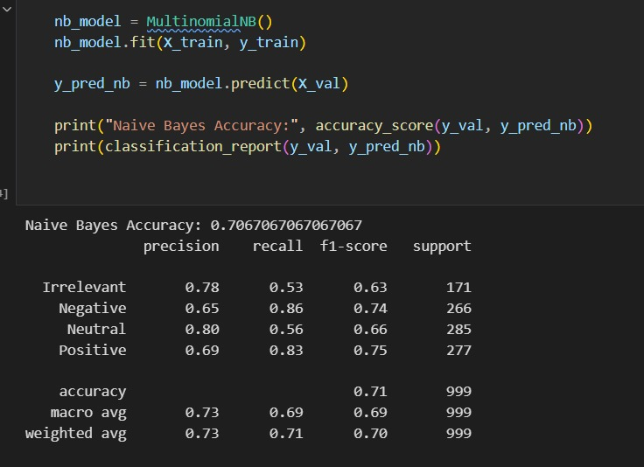
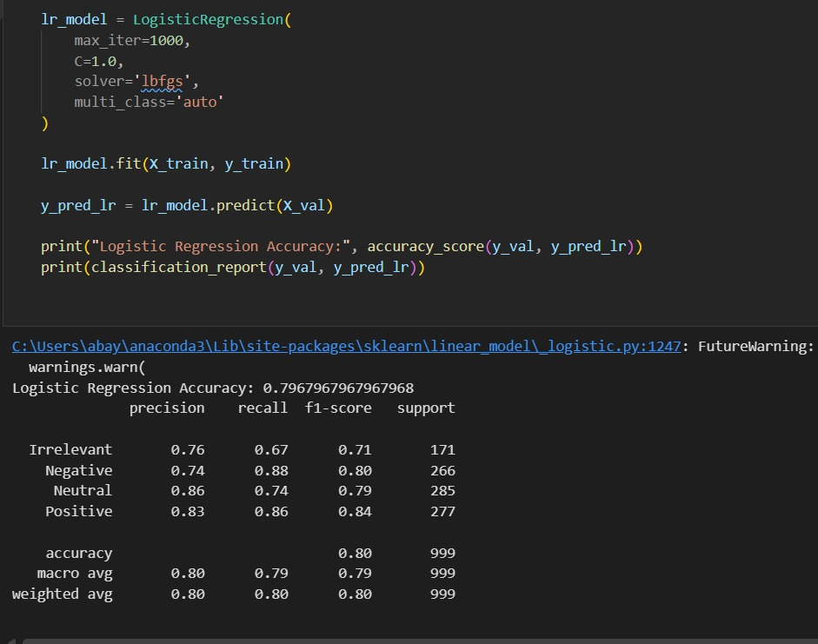

Tuning and Improvements:
- Increased max_iter to 1000 in Logistic Regression for convergence.
- Used TF-IDF vectorization with 5000 features for better text representation.
Performance Evaluation:
- Calculated accuracy and macro F1-score for each model.
- Plotted confusion matrices to analyze classification errors.
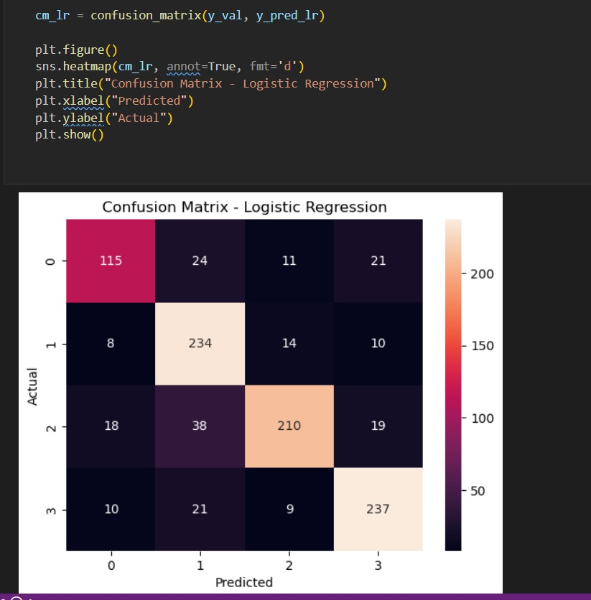

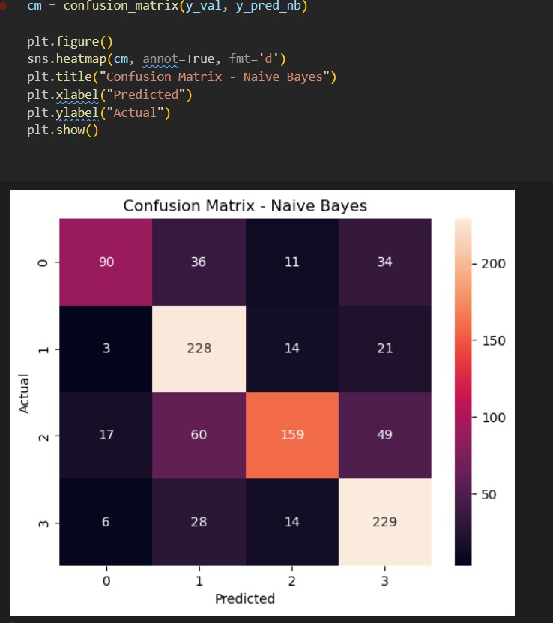

5. Model Development & Evaluation
Objective:
Implement at least two machine learning models for sentiment classification: a baseline model and an improved/optimized model.
Models Selected:
- Naive Bayes (MultinomialNB) – baseline model, simple and fast for text classification.
- Logistic Regression – improved model, allows hyperparameter tuning and usually performs better on TF-IDF features.

Objective:
The goal of this stage is to evaluate and compare the performance of our models using appropriate metrics and visualizations. This allows us to determine which model is better for sentiment classification.
Evaluation Metrics:
- Accuracy: The proportion of correctly predicted tweets.
- Macro F1-score: Average F1-score across all classes, useful for imbalanced datasets.
- Confusion Matrix: Visual representation of true vs predicted labels.
Model Performance Comparison:
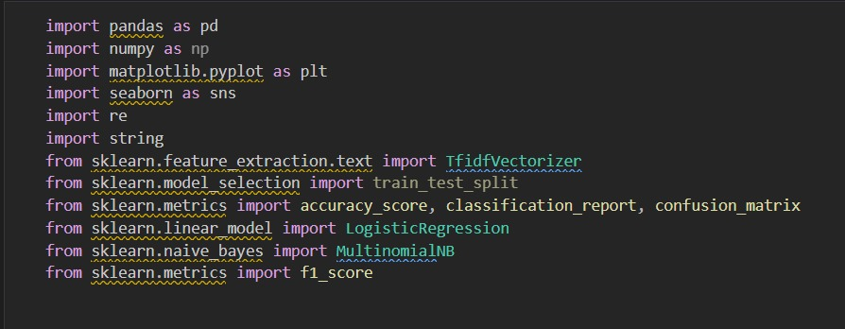
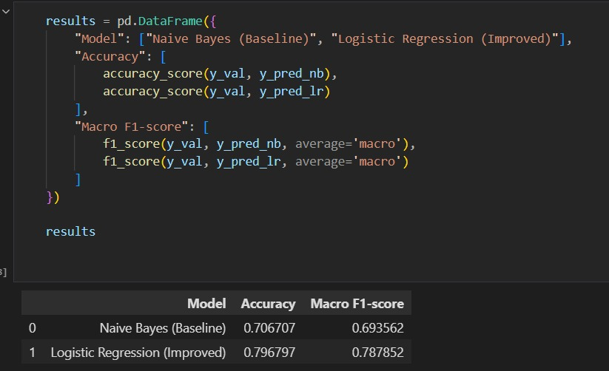

Findings:
- Logistic Regression achieved higher accuracy and macro F1-score than Naive Bayes.
- Confusion matrices show that Logistic Regression reduces misclassifications, especially for minority classes.
- Naive Bayes works reasonably well as a baseline, but Logistic Regression is more robust for this dataset.

7. Discussion & Conclusion (10 points)
Discussion:
Our analysis and model evaluation show that Logistic Regression performs better than Naive Bayes for Twitter sentiment classification. This is likely due to its ability to effectively handle sparse TF-IDF features and model complex decision boundaries.
Limitations:
- The dataset is slightly imbalanced, which may affect predictions for minority classes.
- Tweets are short and often contain slang, abbreviations, or emojis, which can reduce the model's understanding of the text.
- We did not use deep learning models such as LSTM or BERT, which could potentially improve accuracy.
Future Improvements:
- Apply advanced NLP techniques, such as word embeddings (Word2Vec, GloVe) or transformer models (BERT, RoBERTa).
- Use data augmentation or oversampling techniques to address class imbalance.
- Incorporate sentiment-specific features, such as emojis, hashtags, and context-based analysis.
Conclusion:
In this project, we successfully classified tweets into positive, negative, and neutral categories using machine learning models. Logistic Regression achieved the highest accuracy and F1-score. The study demonstrates that traditional machine learning models, combined with proper preprocessing and feature engineering, can effectively analyze public sentiment on social media.

